**NaaS: Navigation as a service**

**Problem Statement**

When we consider a massive public structure like airports and railway stations and also commercial centres like shopping malls, people face a few problems that aren't addressable by traditional methods. A few of them are

* 1. Finding the parking space , fastest route to check-in counters , terminals or gates , ATM’s , restrooms , Belt-drives , exit and public transports like cab and bus at airports to finding the right platforms , ticket and enquiry counter , waiting rooms, food court etc at these structures is troublesome and indeed consumes a lot of time.

1. Footfall analysis and measurement of Influx/Outflux of customers is also difficult. The

measurement of visitor flows can benefit the management in analysing “heatmaps” where most customers visit and the retail centres can be rented according to the customers.

1. Staff management can also be a challenge in these huge structures. Eg. Management of Cleaning staff. Personnel / Staff tracking is required to relocate services where needed the most. Hence staffs and personnel should be monitored remotely along with the instructions to serve the customers better.

With all these requirements satisfied, a revenue model must also be framed for maintenance of the system which solves the above mentioned problems.

**A High Level Architecture and Flow Diagram**

Our idea is mainly meant for public places like airports and railways and also for commercial places like shopping malls. They have a vast and complex infrastructure and it’s always a difficult task to keep track of all things within it. We can deploy indoor navigation system which has the following functionalities.

1. **Location based services (LBS)**​: For Convenience of the users,Indoor positiondetermination is an important consideration for retail – indoor navigation helps clients find their way in large supermarkets and malls via app. Also , it can help in increasing sales by providing premium ads and coupons through push-notifications. But the technology is equally suitable for public buildings with shopping areas, such as airports and railway stations. Depending on the application case, positioning is realized with the help of beacons, Wi-Fi or VLC.
2. **Staff Tracking**​: In complex buildings it can be necessary to determine the position ofemployees. For example it can be beneficial to find out the position of security staff members, when there is an alert. Employee apps are another field of application. Employees can book conference rooms, make appointments with colleagues (buddy finder), navigate in the building and see the canteen plan. The technology can also help in the field of workplace management.
3. **Footfall analysis and Visitor Flows:**​or operators of shopping centers, airports, trade fairs,railway stations etc. it is interesting to know how many visitors stay at a certain place at a certain time and how they move. This way, it is possible to display on a heat map, which places are most frequented – which can be useful for the security staff and others. An alarm can be given when a predefined amount of people stays at a point in the building. After that, actions can be triggered, for example an unscheduled cleaning or a redirection of itineraries. For the marketing department it is interesting to know such numbers. They can also be used to direct people to certain shops or advertising spaces. Organizers of trade fairs profit from the technology as they get some precise visitor numbers when negotiating with exhibitors.

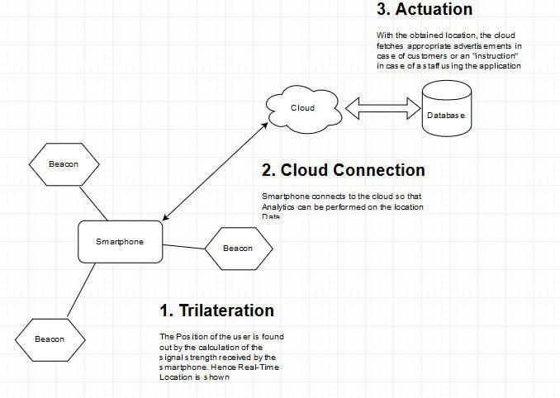

*Figure: A Very High Level View of the flow*

**Smartphone solution**

A smartphone app is perhaps the best solution to all the problems described above.

Smartphone will be used as a tracking device for indoor navigation.

Whenever a smartphone user comes under the range of BLE beacons his/her coordinates are collected for indoor positioning and navigation and if the user is standing near vicinity of a retail store or food court then he/she can be provided with push-notifications like coupons and premium advertisements.

Apart from Advertisement, analytics can be performed on the location data so that better service can be provided for the customers with regards to staff management. The amount and the type of staff is better maintained and also gets better and better through Machine Learning.

The Staff can use the app to follow the instructions which will be in accordance with the customer’s needs.

**Tools and Platforms that will be used**

**Software**

1. Google Beacon Platform
2. Android Studio
3. Flask Microframework
4. Google Firebase
5. AWS EC2
6. AWS RDS
7. Databases: MySQL and MongoDB

**Hardware**

1. Bluetooth Beacons
2. Android Smartphone

**Functional Flow**

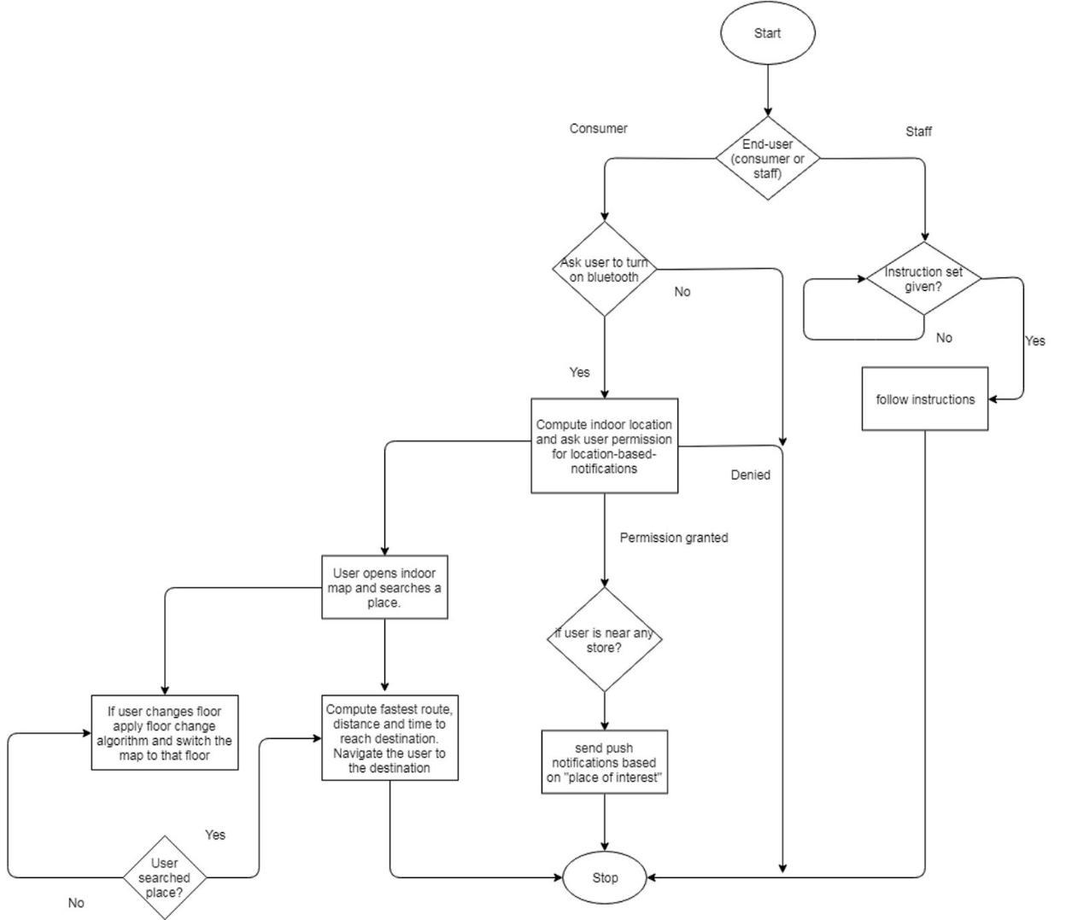

*Fig: Flowchart*

The Functional Flow for the three scenarios are given below:

1. Indoor Navigation
   1. The Beacon signals will be caught by the smartphone and trilateration will fetch the real time location of the user.
   2. The real time location is displayed on the smartphone screen and relevant guidance is given to the user if he/she wants to navigate to a particular location.
   3. The location is tagged with the nearby “places of interest” i.e. coffee shops, restaurants etc. and with the bluetooth ID and is sent to the server.

<Location, Bluetooth ID, {Places of Interest}> is the payload

This feature will be helpful for the customers to navigate in instances such as a. Finding the platform to aboard train/airplane

Compare and buy

* This option in the app enables users to select the item they want to buy and they can compare items which are available in different shops either by rating or by price.
* In the app it will show the item details such as store name, category, price and rating.
* Users can click on store name displayed then it will directly navigate them to the store.
* It is a much easier way for the users to find an item in a huge mall.

b. PalFinder: PalFinder will be a feature where a person can meet another person by navigating to his current position. Talking over the phone or texting is a non intuitive way of finding any friend in such huge structure especially when the structure is not familiar. Curious Kids can also be tracked by the parents and hence will be ensured that their kids will be safe and won’t get lost in pursuit of curiosity!

1. Premiums and Coupons
   1. Based on the nearby “Places of interest”, coupons and premiums will be delivered to the customer’s smartphone so that the customer can know about the best offers and can make an immediate selection for a place for shopping/recreation etc

.

1. Staff Management
   1. Staffs can also use the app for getting “instructions” from the server. Their bluetooth ID is stored in the database to recognise them as Staffs and to distinguish between staffs and other users.
   2. ML and Analytics is deployed to analyse the situation in any particular location. Eg. 1) A Huge crowd in Platform 21 and a train inbound in Platform 21 indicates that additional security staff must be deployed to handle the situation.

2) A huge crowd without any trains inbound or outbound may indicate a condition like medical emergency or any accident or any other incident.

ML algorithms will be able to predict the density of customers according to the season/ time of the day and hence adequate number of staffs can be deployed and hence money can be saved.

It can also predict to an extent about the dynamic nature of the staff. Eg. Cleaning staff covering all the floor areas. And hence staffs can be incentivised by coupons as a token of appreciation.

**Cloud Connectivity with Database Interaction**

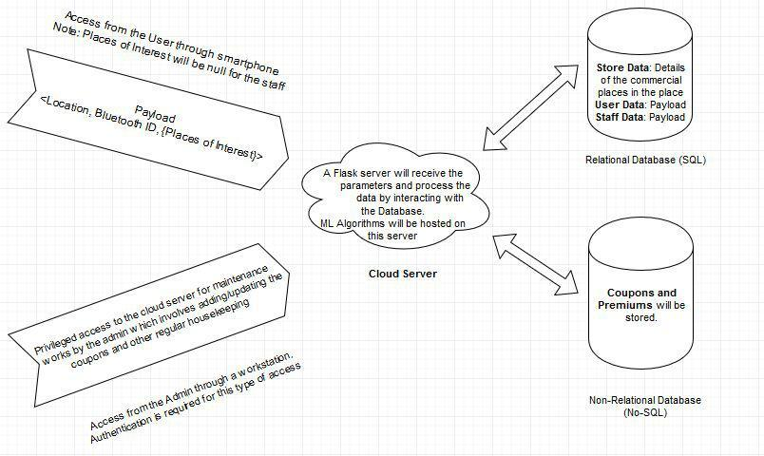

*Figure: Cloud Connectivity with Database Interaction*

**Data Analytics to be deployed**

Data Analytics algorithms are to be deployed in our application. Since we aren’t collecting any personal data from the user, we wouldn’t be able to deploy machine learning algorithms since they aren’t feasible. The Data analytics programs make use of the Numpy and Pandas Library and are helpful in

1. Footfall analytics: The count of the people, gender and age of the people that enter a particular restaurant or a store can be worked upon to know the customers well.
2. Heatmap Generation: The density of people in a particular area for timely dispatch of staff members. Using functions, we can show the heatmap for the user.
3. Prediction of the amount of people: Again, as the previous point, it will help the management in managing the staffs.

**Physical system architecture (Beacons)**

We shall put information that how we triangulate the position and its interaction with android app through server (top level)

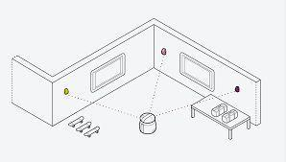

*Figure: Triangulation*

**Challenges :**

1. If user stands exactly in between two stores, he might get multiple notification at the same time which can be overwhelming.
2. Since this is a centralized architecture, failure of server may result in loss of service across all beacons.

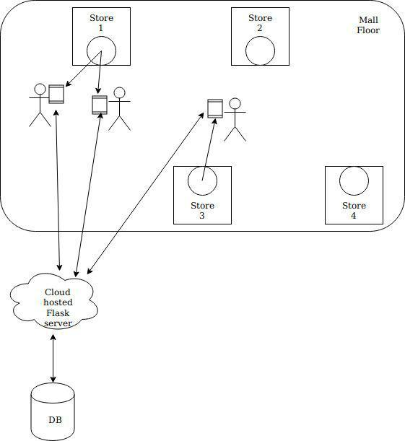

*Figure: Human Interaction*

**Human Interaction**

Users will approach a store and signals emitted by the beacon installed in the store, will be captured by the user’s smartphone. The location of the user along with the tags and Bluetooth ID is sent to the server by the Android app. The server then stores all the information which will pave way for footfall analysis. The coupons and premiums relevant to the store near which the users are located are displayed to the user on their smartphone through notifications.

**Algorithm**

1. The User Downloads and Installs the app. Each user is identified by the smartphone’s bluetooth address.
2. Some basic questions will be answered by the user to determine the user’s age, gender and other attributes. No personal information is sought after and privacy is protected.
3. The user than can get the current coordinates in tha layout map of the structure a.k.a. Airport, railway station etc.
4. Navigation can be done by entering a location’s name. On entering a valid location, one or more ‘route maps’ will be obtained. The user can choose any one of the route.
5. The recommended routes will have the shortest distance and/or the routes where the “traffic” will be less. Hence effective traffic management of the people is done.
6. When the user decides for some recreation, coupons and premiums will be delivered to the smartphone based on the attributes of the person. Note that attribute will be asked only once per user.
7. The person can also locate a friend or a family member and navigate to his/her position without the hustle of asking random people or looking up sign boards.

Using analytics we will analyze the previous data. For example, On Monday morning most of the people brought orange juice with potato chips from a particular store. So using this data we can tell store owners to give combo offers and sell products which will give them more profit. And then this type of offers can be given to customers as notifications when they are near that store.

**Plan for user Testing**

We are developing a beacon integrated android application which will assist users in navigating

inside large structures like airports, railways and commercial centres like supermarket and

malls.

Pre-requisites :

* App installation on the smartphone
* Beacons to place/fix inside the building
* Bluetooth (BLE) has to be activated in the mobile device

For testing the application we have created some task scenarios which will be used to identify usability errors and make the application robust. ***Scenario****​*​**1**​: Indoor positioning test

* User walks inside a structure
* Opens the app
* Turns on bluetooth

***Result****​*: App must be able to locate user on the map.

***Scenario****​*​**2**​: Indoor navigation test

Case 1: User searches for a place

* Turns on bluetooth
* Opens the app
* Selects on search place
* Gives his input

***Result****​*: App should be able to locate and navigate the user to the nearest spot.

Case 2 : User changes floor

* As soon as the user changes the floor
* The app should detect it through beacons signal.
* And the map should switch to that floor.

***Result****​*: App should detect the floor change and update the map..

***Scenario 3****​*: Push-notification test

* When the user is inside or in the vicinity of a store/restaurant
* User must be notified about that place through coupons and premium advertisements. ​***Result*** *​*: User should receive push-notifications.

***Challenges****​*:

* Beacon Placement
* Building an indoor map
* To ensure map navigation seamlessly adapts to changes in the map.